13. Develop a system using UML for BPO Management System. The system should hold the details of the customer and all approaches to it. It is managed by the central system.

ACTIVITY DIAGRAM

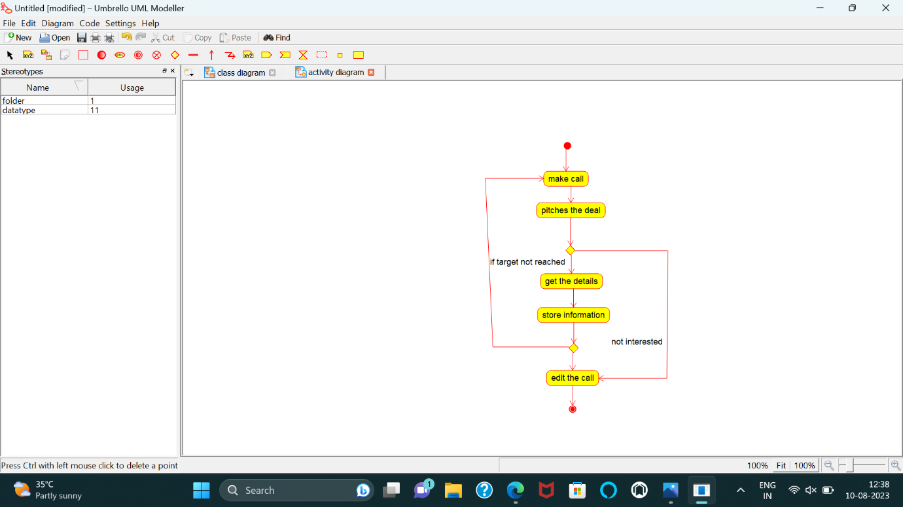

STATE DIAGRAM

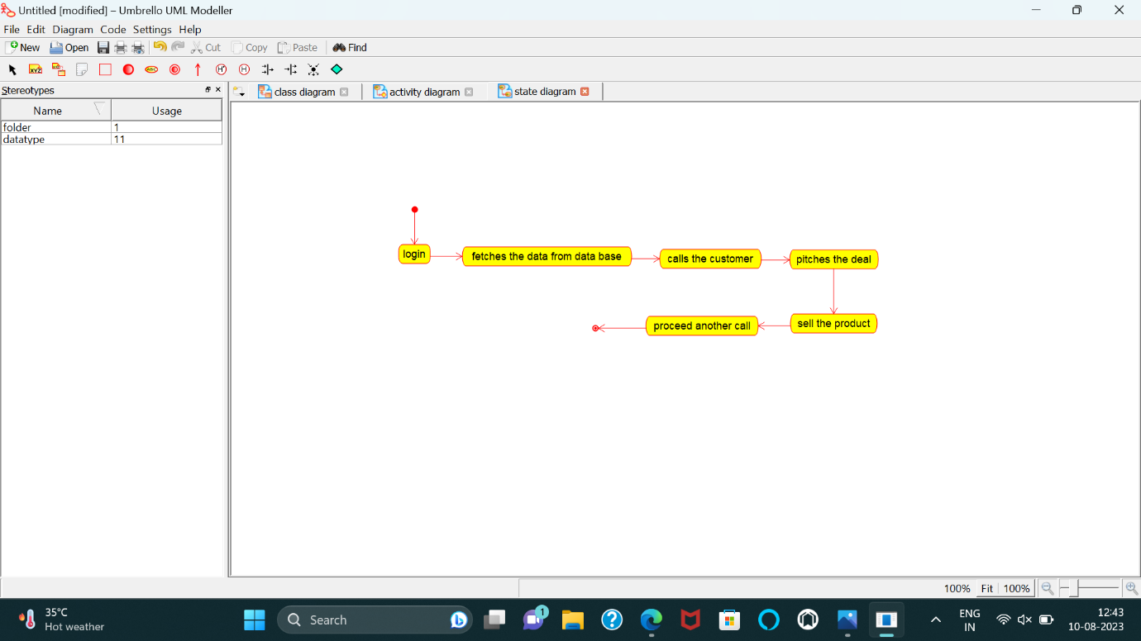

CLASS DIAGRAM

